SIMATS ENGINEERING

ASSESSMENT TOOL 1

COURSE NAME : Database Management Systems
COURSE CODE: CSA0504

COURSE OUTCOME COVERED
CO1: Analyze DBMS architecture, different data models, schema types, and design ER/EER diagrams, relational schemas for case-based scenarios by identifying entities and relationships. (BL1, BL2)

Activity Tool : Short Answer Text(High)
Assessment Tool Weightage: 40%
QUESTIONS
Q. No | Question | Bloom's Level
1 | Explain schema and instance with examples. Distinguish between logical schema, physical schema, and view schema. | BL1 – Remember
2 | Identify the entities, attributes, and relationships for a Bank Management System and construct its ER diagram. | BL2 – Understand
3 | Explain the Extended ER (EER) model. Describe the concepts of generalization, specialization, and aggregation. | BL2 – Understand
4 | Design an EER diagram for a Hospital Management System incorporating inheritance and weak entities. | BL2 – Understand
5 | Explain the role of a DBA (Database Administrator) and the responsibilities associated with the position. | BL1 – Remember

1. Schema and Instance
Schema
A schema is the overall structure or design of a database. It defines how the data is organized, including tables, attributes, relationships, and constraints. A schema changes very rarely.
Example:
STUDENT(Student_ID, Name, Department, Age)
COURSE(Course_ID, Course_Name, Credits)
This defines the structure of the database.
Instance
An instance is the actual data stored in the database at a particular moment. It changes frequently as records are added, updated, or deleted.
Example:
STUDENT Table
Student_ID | Name | Department | Age
101 | Rahul | CSE | 20
102 | Priya | ECE | 21
The above records represent one instance of the database.
Difference Between Schema and Instance
Schema | Instance
Blueprint or structure of the database | Actual data stored in the database
Defined during database design | Changes frequently
Rarely changes | Changes whenever data is inserted, updated, or deleted
Also called Intension | Also called Extension

Types of Database Schemas
1. Logical Schema
- Describes the logical structure of the database.
- Specifies tables, attributes, relationships, and constraints.
- Independent of physical storage.
Example:
EMPLOYEE(Emp_ID, Name, Salary, Dept_ID)
DEPARTMENT(Dept_ID, Dept_Name)

2. Physical Schema
- Describes how the data is physically stored in the database.
- Includes file organization, indexes, storage blocks, and access methods.
- Managed by the DBMS.
Example:
- EMPLOYEE table stored in a B+ tree index.
- Data stored in fixed-size disk blocks.

3. View Schema (External Schema)
- Describes how different users view the database.
- Shows only the required data and hides the rest for security and simplicity.
- Different users can have different views.
Example:
Student View
Student_ID | Name | Department
Accounts Office View
Student_ID | Name | Fee_Status
Each user sees only the information relevant to their work.

Difference Between Logical, Physical, and View Schema
Logical Schema | Physical Schema | View Schema
Defines the logical structure of the database | Defines how data is stored physically | Defines the user's view of the database
Includes tables, attributes, and relationships | Includes storage details, indexes, and file organization | Includes only the required data for users
Independent of physical storage | Dependent on storage devices | Independent of physical storage
Used by database designers | Used by database administrators (DBAs) | Used by end users and applications
Summary
- Schema : The blueprint or structure of the database.
- Instance : The actual data present in the database at a given time.
- Logical Schema : Defines the logical organization of data.
- Physical Schema : Defines how data is physically stored.
- View Schema : Defines customized views of the database for different users.

2. Bank Management System – Entities
Main Entities
- Customer
  - Customer_ID (PK)
  - Name
  - Address
  - Phone
- Account
  - Account_No (PK)
  - Account_Type
  - Balance
- Branch
  - Branch_ID (PK)
  - Branch_Name
  - Location
- Loan
  - Load (PK)
  - Loan_Amount
  - Loan_Type
- Employee
  - Employee_ID (PK)
  - Name
  - Designation
  - Salary
Attributes & Relationships
Attributes
- Customer: Customer_ID, Name, Address, Phone
- Account: Account_No, Type, Balance
- Loan: Loan_ID, Amount, Type
- Branch: Branch_ID, Name, Location
- Employee: Employee_ID, Name, Designation, Salary
Relationships
- Customer owns Account
- Branch maintains Account
- Customer takes Loan
- Branch issues Loan
- Branch employs Employee
Bank Management System – Entities
Main Entities
- Customer
  - Customer_ID (PK)
  - Name
  - Address
  - Phone
- Account
  - Account_No (PK)
  - Account_Type
  - Balance
- Branch
  - Branch_ID (PK)
  - Branch_Name
  - Location
- Loan
  - Loan_ID (PK)
  - Loan_Amount
  - Loan_Type
- Employee
  - Employee_ID (PK)
  - Name
  - Designation
  - Salary
Attributes & Relationships
Attributes
- Customer: Customer_ID, Name, Address, Phone
- Account: Account_No, Type, Balance
- Loan: Loan_ID, Amount, Type
- Branch: Branch_ID, Name, Location
- Employee: Employee_ID, Name, Designation, Salary
Relationships
- Customer owns Account
- Branch maintains Account
- Customer takes Loan
- Branch issues Loan (1:M)
- Branch employs Employee (1:M)
ER Diagram

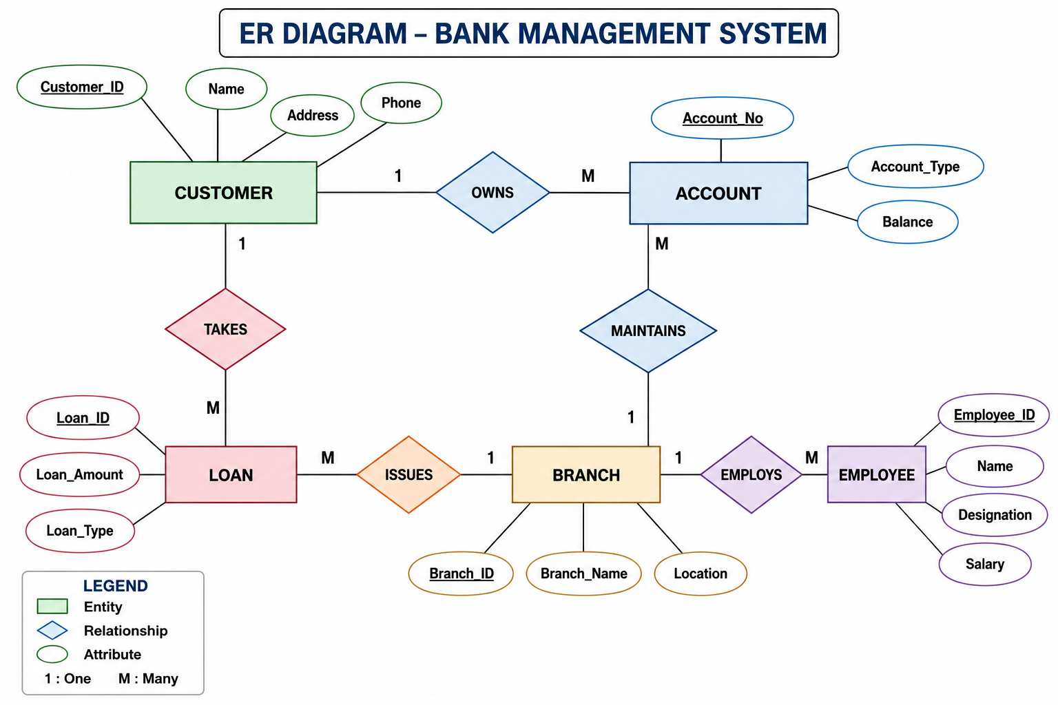
Entities
- Customer
- Account
- Branch
- Loan
- Employee
Relationships
- Customer → Owns → Account
- Branch → Maintains → Account
- Customer → Takes → Loan
- Branch → Issues → Loan
- Branch → Employs → Employee
Result: The ER diagram models the main objects and their relationships in a Bank Management System, helping design an efficient database.

3. Extended ER (EER) Model
The Extended Entity-Relationship (EER) Model is an enhanced version of the ER model. It includes advanced concepts such as generalization, specialization, aggregation, and inheritance, making it suitable for representing complex real-world databases.
Features of EER Model
- Supports inheritance of attributes and relationships.
- Represents superclass and subclass entities.
- Handles complex relationships using aggregation.
- Provides a more detailed database design than the basic ER model.
1. Generalization
Definition:
Generalization is the process of combining two or more lower-level entities with common features into a higher-level entity called a superclass.
Example:
- Student and Teacher have common attributes like Name and Address.
- They can be generalized into a superclass Person.
2. Specialization
Definition:
Specialization is the process of dividing a higher-level entity into lower-level entities based on their unique characteristics.
Example:
Employee can be specialized into:
  - Manager
  - Engineer
  - Clerk
3. Aggregation
Definition:
Aggregation is a technique used to treat a relationship between entities as a higher-level entity so that it can participate in another relationship.
Example:
- An Employee works on a Project.
- The relationship Works_On is aggregated and linked to Manager, who supervises it
Generalization | Specialization
Bottom-up approach | Top-down approach
Combines similar entities | Divides an entity into subclasses
Creates a superclass | Creates subclasses
Focuses on common features | Focuses on unique features
Advantages of EER Model
- Represents complex database structures.
- Reduces redundancy through inheritance.
- Improves database design and flexibility.
- Makes real-world modeling easier.
Conclusion
The EER model extends the basic ER model by introducing generalization, specialization, and aggregation. These concepts help design databases that are more organized, flexible, and capable of representing real-world scenarios accurately.
4. EER Diagram for Hospital Management System
Entities
- Person (Superclass)
  - Person_ID (PK)
  - Name
  - Age
  - Gender
  - Address
  - Phone
- Specialization (Inheritance)
  - Doctor
    - Doctor_ID
    - Specialization
    - Salary

  - Patient
    - Patient_ID
    - Blood_Group
    - Disease
    - Admission_Date
- Department
  - Dept_ID (PK)
  - Dept_Name
  - Location
- Appointment
  - Appointment_ID (PK)
  - Date
  - Time
- Medical_Record (Weak Entity)
  - Record_No (Partial Key)
  - Diagnosis
  - Prescription
  - Treatment
Relationships
- Person → (Specialization) → Doctor, Patient
- Doctor Works_In Department (Many-to-One)
- Patient Books Appointment (One-to-Many)
- Doctor Attends Appointment (One-to-Many)
- Patient Has Medical_Record (Identifying Relationship)
  - Medical_Record is a Weak Entity because it cannot exist without a Patient.
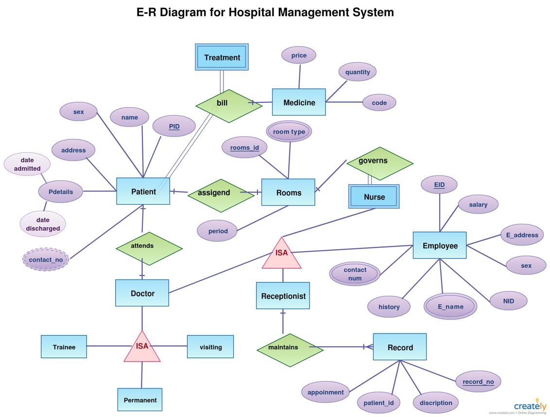
Key EER Concepts Used
- Inheritance (Generalization/Specialization):
  - Person is the Superclass.
  - Doctor and Patient are Subclasses inheriting common attributes.
- Weak Entity:
  - Medical_Record depends on Patient for its existence.
  - It uses Record_No as a partial key and is identified by Patient_ID + Record_No.
Features
- ✔ Superclass: Person
- ✔ Subclasses: Doctor, Patient
- ✔ Weak Entity: Medical_Record
- ✔ Relationships: Works_In, Books, Attends, Has
- ✔ Suitable for hospital database design and exams
5. Role of a Database Administrator (DBA)
A Database Administrator (DBA) is a professional responsible for managing, maintaining, securing, and ensuring the efficient operation of a database system. The DBA ensures that the database is always available, reliable, and performs well for users and applications.
Responsibilities of a DBA
1. Database Installation and Configuration
- Installs DBMS software.
- Configures database settings for optimal performance.
2. Database Design
- Creates and maintains database structures such as tables, indexes, and relationships.
- Ensures efficient database organization.
3. Security Management
- Creates user accounts and assigns permissions.
- Protects the database from unauthorized access.
4. Backup and Recovery
- Performs regular database backups.
- Restores data in case of system failure or data loss.
5. Performance Monitoring
- Monitors database speed and resource usage.
- Optimizes queries and indexing for better performance.
6. Data Integrity
- Ensures data is accurate, consistent, and free from corruption.
- Enforces constraints and validation rules.
7. Maintenance and Updates
- Applies software patches and upgrades.
- Performs routine maintenance to keep the database running smoothly.
8. Troubleshooting
- Identifies and resolves database errors and performance issues.
- Minimizes downtime.
Role | Responsibility
Database Setup | Install and configure DBMS
Security | Manage users and permissions
Backup | Backup and recover data
Performance | Monitor and optimize database
Maintenance | Update and maintain the database
Data Integrity | Ensure accuracy and consistency
Troubleshooting | Fix database problems
Conclusion
A Database Administrator (DBA) plays a vital role in ensuring that databases are secure, reliable, efficient, and available. The DBA is responsible for installation, maintenance, security, backup, performance tuning, and recovery of database systems.

